Solution of Theory part

Q1
- (you can use either the sentence or equations)
The mean is the average of all the values. E.g.
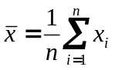
The median is the value such that half of the values lie on either side of it.
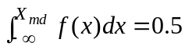 X continuous
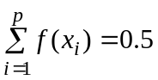 X discrete

The mode is the value x having largest associated probability or most frequently occurring.
For discrete variable the mode is the value of x which appear more times than any others or associated with
max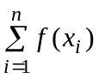

For a continuous variable the mode is the value of x satisfying
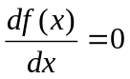 and 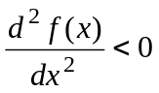

- Example: 1, 2, 2, 3. Its mean = 2 = median = mode
Many other examples.

- Coefficient of variation CV is defined as STD/Mean. It is dimensionless and more convenient for cross comparison between variables or spaces.

d. The equation is used for calculating the second central moment or variance.

Q2.
- Type I error: reject a true hypothesis, measured by significance level α.
Type II error: accept a false hypothesis, measured by β.
- As the value of α gets small, the value of β gets large.
Or for the same α value, when the true population is close to the null hypothesized population the β is also getting large. This is because this is increasingly difficult to tell the difference between the two distributions. E.g.
(in the figures, the numbers are not useful for this question, just pay attention on the shaded areas of α and β, which must be clearly and correctly shown)
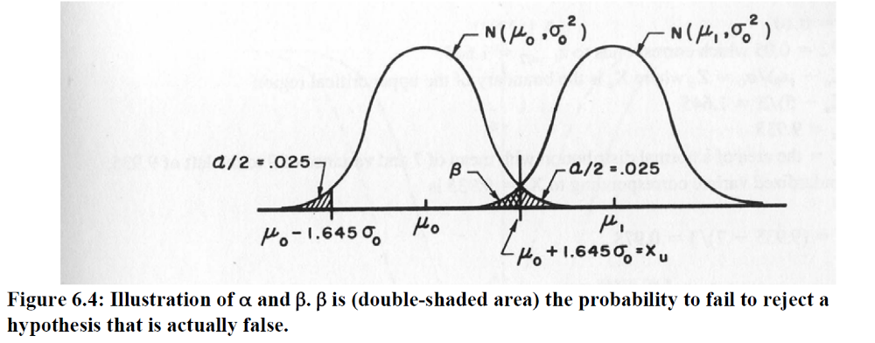
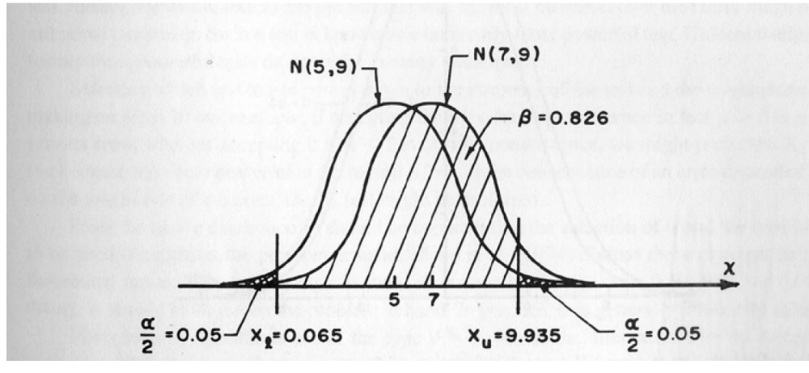

Q2 About time series analysis and stochastic modeling
Answer the following statements with “True” if it is always true, otherwise with “false”
- T (because stochastic process can have deterministic components)
- F (seasonally (daily, monthly, etc) varying times series are not stationary)
- F (independence and stationarity are different)
- T (yes, stationary + independent = white noise = purely random)
- F (Guassian = normal distributed)
- F (see above)
- F (white noise series can have other distributions, like Person III)
- F (lnXt is symmetric, but not Xt)
- F (AR(1) is for stationary time series with short momery, autocorrelation is significant in time lag 1)
- F (see above)

Calculus part

Q3
a) 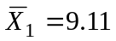 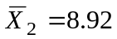
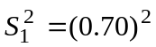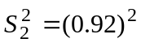
Ho: 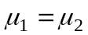 Ha: 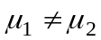

Assumption: small sample size, use T-test
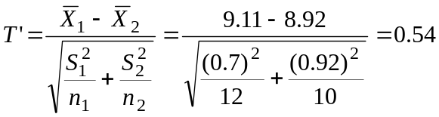

Ho rejects if T’ > (w₁t₁+w₂t₂)/(w₁+w₂)

Where 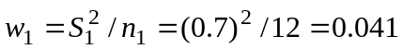
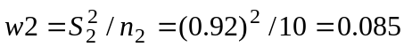
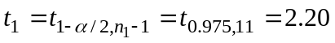
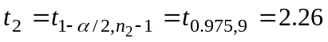
and 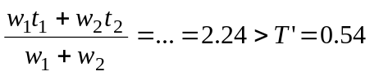
Therefore the hypothesis of the means are not affected (i.e. two means are equal) cannot be rejected.

b) Fc = 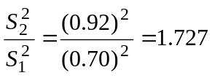 (remember Fc MUST BE > 1 !!!!!!!!!)
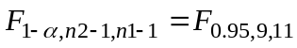≧2.8 (from F distribution table)
Since Fc <

Therefore the hypothesis of the variances are not affected cannot be rejected.

Q5
- Cumulative histograms (omitted)
From the graph we can see that Data A is more centered in the middle class (100 – 150), while station B has large number of increase in the second class and large number of decrease in the last class.

Q≤50 | 50<Q≤100 | 100<Q≤150 | 150<Q≤250 | Q>250
6 | 24 | 35 | 15 | 10 | Oj | N=90
5 | 25 | 20 | 26 | 14 | Ej | N=90
1 | -1 | 15 | -11 | -4 | (Qj-Ej)
1 | 1 | 225 | 121 | 16 | (Oj-Ej)^2 | 364
0.2 | 0.04 | 11.25 | 4.65 | 1.14 | (Oj-Ej)^2/Ej | Χ²_{c}=17.28
Χ²_{1-α, k-0-1} = Χ²_{0.95,5-1} =9.488 (from Table. The table shows value on right side) < Χ²_{c}=17.28
Decision: the hypothesis of A and B belonging to same distribution is rejected.

Q6
1.
- Design flood, Q_{T} – is the magnitude of the peak flow for a selected/predetermined design level as measured by return period, T (= magnitude of an event that has return period T)
- Return period, T – the average length of time between two events (i.e. floods) of a given magnitude or greater. Roughly, mean value of a series has a T = 2, smallest value has a T=1, and largest value has a T >= n.
- Probability of exceedance
The probability that a given event, Q_{T}, will be exceeded, P(Q>Q_{T})

We have
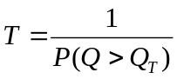

2a) P(Q>q) = 0.75 → P(Q<q) = 0.25
P(ln(Q)<ln(q))=0.25
P(z<(ln(q)-5)/0.5) = 0.25
(ln(q)-5)/0.5 = -0.67
ln(q) = 4.665
q = exp(4.665) = 106 m3/s

2b) P(Q<q) = 0.5 → P(Q>q) = 0.5
therefore q = 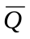 → ln(q) = 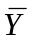 = 5 →q = exp(5) =148 m3/s

or
P(Q<q) = 0.5 →P(z<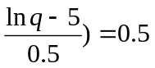→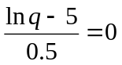
→ ln(q) = 5 →q = exp(5) =148 m3/s

2c) P(Q<100) = P(ln(Q)<ln100) = P(z<(ln100-5)/0.5)
=P(z<-0.79) = 1-P(z<0.79) = 1-0.7852
=0.215

2d) method 1: P(Q>q in one year) = 1/10 = 0.1
P(Q<q in one year) = 1-0.1 = 0.9
P(Q<q every year in 10 years) = 0.9^10 = 0.3487
P(Q>q at least one year in 10 years) = 1- P(Q<q every year in 10 years)
=1-0.3487 = 0.6513

Or method 2:
Risk = 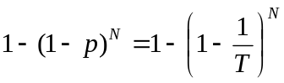
Here: T = 10, N = 10
Risk = at least 1 flood in 10 years =  